ANOVA

Yi Chen

Teachers College, Columbia University

HUDM 5123

Lab Two for Linear Models and Experimental Design

Abstract

Abstract：In this paper, I will provide the brief answer for the questions in the lab 3. Code and detail information will not be covered. Please contact me if you are interested in code.

Keywords: ANOVA

ANOVA

# Task 1: ANOVA

The box plot for two different group in shown in Figure 1. 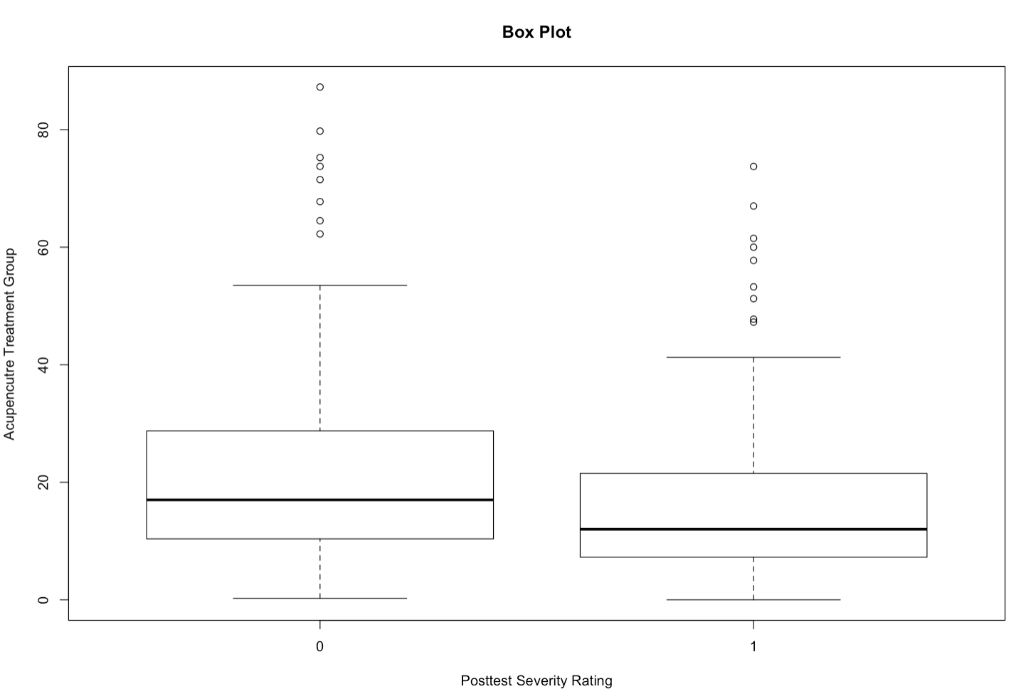

*Figure 1: Box Plot*

# Task 2

Null hypothesis: there is no statistically significant differences between the averages of different position types.

Alternative hypothesis: there are statistically significant differences between the averages of different position types. $F\left(2, 95\right)= 109.59, p<.001$.

Conclusion: position type is a statistically significant predictor of prestige.

# Task 3

The estimated value of intercept in the full model is: 48.5397. This indicates that the average (grand mean) prestige is 35.527 for every position type, when we ignore all the missing data.

The estimated values of slope in the full model are 19.3087 (prof) and -6.2962 (wc). This indicates the distance of prestige of grand mean between ‘prof’ is 19.3087 and ‘wc’ is -6.2962, if we ignore all the missing data. The average prestige for ‘prof is 67.758 and ‘wc’ is 42.243 and ‘bc’ is 35.527.

# Task 4

Null hypothesis: there is no statistically significant differences between the averages of different position types.

Alternative hypothesis: there are statistically significant differences between the averages of different position types. .

Conclusion: position type is a statistically significant predictor of prestige.